Based on the Appium statement, the key technologies involved for different environments can be categorized as follows:

**1. Mobile Automation (iOS, Android, Tizen)**

**Technologies Used:**

* **Android**
  + Uses **UIAutomator2** (default) or **Espresso** for native app testing.
  + Uses **Chromedriver** for automating web applications in Chrome on Android.
* **iOS**
  + Uses **XCUITest** (Apple's official UI testing framework) for native iOS app testing.
  + Uses **SafariDriver** (via WebKit) for automating Safari browser on iOS.
* **Tizen** (Samsung OS for smart devices)
  + Uses **Tizen WebDriver** or Tizen-specific automation tools.

**2. Browser Automation (Chrome, Firefox, Safari)**

**Technologies Used:**

* **Selenium WebDriver**: Appium extends Selenium for browser-based automation.
* **Chromedriver**: Controls Chrome and Chromium-based browsers (Android & Desktop).
* **Geckodriver**: Automates Mozilla Firefox.
* **SafariDriver**: Controls Safari browser on macOS and iOS.

**3. Desktop Application Automation (Windows, macOS)**

**Technologies Used:**

* **Windows**
  + Uses **WinAppDriver** (Windows Application Driver) for automating Windows apps.
* **macOS**
  + Uses **Mac2Driver** (for macOS UI automation based on Apple's APIs).

**4. TV Automation (Roku, tvOS, Android TV, Samsung)**

**Technologies Used:**

* **Roku**
  + Uses **Roku WebDriver** or Telnet-based automation.
* **tvOS (Apple TV)**
  + Uses **XCUITest** (same as iOS).
* **Android TV**
  + Uses **UIAutomator2** (same as Android mobile).
* **Samsung Smart TV**
  + Uses **Tizen WebDriver** (specific to Tizen OS).

**5. Additional Technologies & Tools**

* **Appium Server**: Acts as the bridge between test scripts and the device under test.
* **Appium Clients**: Libraries available in multiple languages (Java, Python, JavaScript, C#, Ruby, PHP).
* **WebDriver Protocol**: Appium uses the WebDriver protocol (same as Selenium) to communicate with devices.

**Conclusion**

Each environment in Appium relies on different technologies for automation:

* **Mobile apps** → UIAutomator2, Espresso (Android) / XCUITest (iOS)
* **Web browsers** → Selenium WebDriver, Chromedriver, Geckodriver, SafariDriver
* **Desktop apps** → WinAppDriver (Windows), Mac2Driver (macOS)
* **TV platforms** → Roku WebDriver, XCUITest (tvOS), UIAutomator2 (Android TV), Tizen WebDriver (Samsung TV)

Appium supports multiple programming languages for writing test scripts through its **client libraries**. These languages interact with the **Appium Server** via the **WebDriver API**.

**Programming Languages Supported by Appium**

1. **Java** (Most popular for Appium automation)
2. **Python**
3. **JavaScript** (Node.js)
4. **C#**
5. **Ruby**
6. **PHP**

**How Each Language Works with Appium**

| **Language** | **Appium Client Library** |
| --- | --- |
| **Java** | [io.appium:java-client](https://github.com/appium/java-client) |
| **Python** | [appium-python-client](https://github.com/appium/python-client) |
| **JavaScript (Node.js)** | [webdriverio](https://webdriver.io/) |
| **C#** | [Appium.WebDriver](https://github.com/appium/appium-dotnet-driver) |
| **Ruby** | [appium_lib](https://github.com/appium/ruby_lib) |
| **PHP** | [php-webdriver](https://github.com/facebook/php-webdriver) |

**Which Language Should You Choose?**

* **Java** → Best for large-scale projects, widely used in Android automation.
* **Python** → Simple and quick for scripting and automation.
* **JavaScript** → Good for web and mobile automation (e.g., using WebdriverIO).
* **C#** → Ideal for .NET-based projects.
* **Ruby** → Preferred in some older testing frameworks.
* **PHP** → Less common, but available for PHP-based teams.

If you're working with **Android TV Box automation**, Java or Python are the best choices, as they have **strong support for UIAutomator2**.

**Introduction to Appium Architecture**

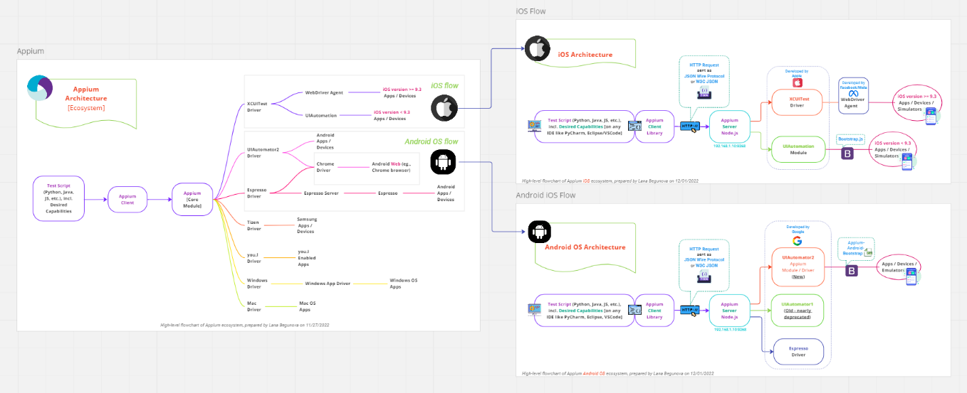  
*source from* [*https://github.com/lana-20/appium-architecture?tab=readme-ov-file*](https://github.com/lana-20/appium-architecture?tab=readme-ov-file)

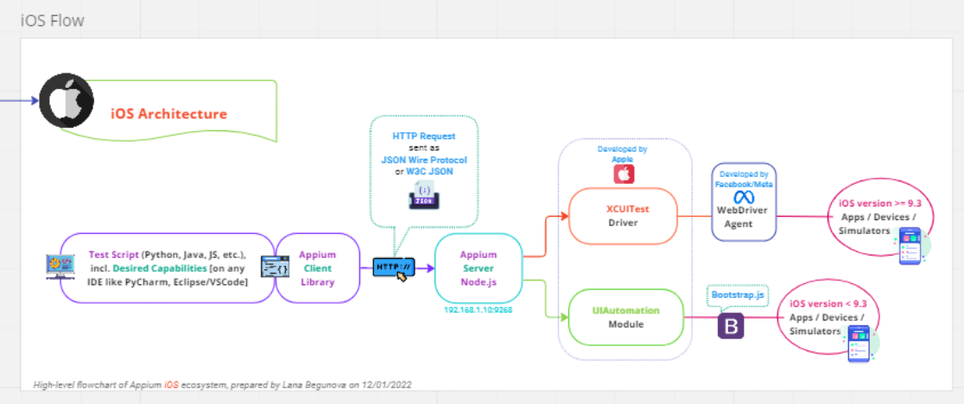

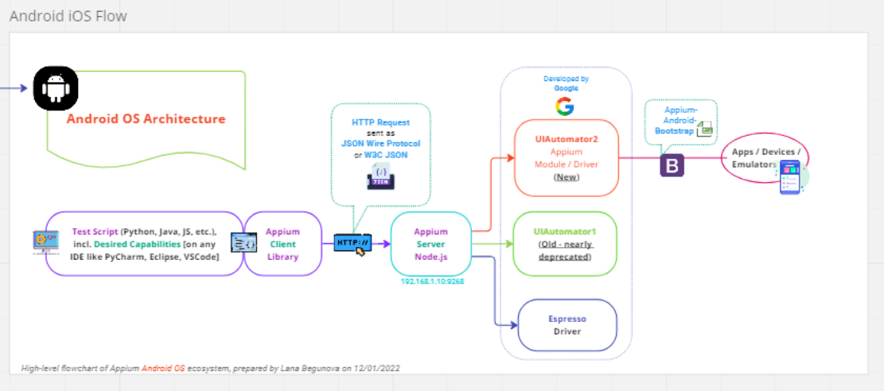

Appium is an **open-source automation framework** that enables **cross-platform UI testing** for **mobile (iOS, Android, Tizen), web (Chrome, Safari, Firefox), and desktop applications (Windows, macOS)**. It follows a **client-server architecture** and interacts with devices via automation drivers.

**1. Appium Ecosystem Overview**

The Appium ecosystem consists of three key components:

1. **Test Script**:
   * Written in **Python, Java, JavaScript, C#, Ruby, or PHP**.
   * Specifies **desired capabilities** such as platform, device, and app under test.
   * Runs in any **IDE** (PyCharm, Eclipse, VSCode, etc.).
2. **Appium Client**:
   * Sends **HTTP requests** (WebDriver Protocol / W3C JSON Wire Protocol) to the Appium Server.
   * Uses language-specific Appium libraries.
3. **Appium Server (Node.js)**:
   * Processes the request and forwards commands to the appropriate **driver**.
   * Communicates with real devices, emulators, or simulators.
   * Runs on a specific **IP and port** (e.g., 192.168.1.109:258).

**2. Appium Core Module & Drivers**

Appium uses **drivers** to interact with different platforms:

**iOS Automation Flow**

* Uses **XCUITest Driver** (for iOS >= 9.3) and **UIAutomation Driver** (iOS < 9.3).
* WebDriver Agent acts as a bridge to execute commands on the device.

**Android Automation Flow**

* Uses **UIAutomator2 Driver** (developed by Google) for modern Android apps.
* **Espresso Driver** for testing Android apps using the Espresso framework.
* **ChromeDriver** for testing web apps in Chrome.

**Other Platforms**

* **Tizen Driver** → Automates Samsung apps.
* **Windows Driver** → Uses **Windows App Driver** to automate Windows OS applications.
* **Mac Driver** → Automates macOS apps.
* **you.i Driver** → Automates apps using the you.i framework.

**3. Communication Flow**

1. **Test scripts** send HTTP requests via the Appium Client.
2. **Appium Server (Node.js)** receives requests and routes them to the correct driver.
3. The **driver interacts with the device or emulator/simulator** and executes actions.
4. **Test results** are returned to the client.

**4. Key Benefits of Appium Architecture**

✅ **Cross-platform** – Write one test script for Android, iOS, and Web.  
✅ **Supports multiple languages** – Java, Python, JavaScript, etc.  
✅ **No need to recompile the app** – Unlike other tools, Appium does not require modifying the app under test.  
✅ **Works with real devices & emulators/simulators** – Supports both local and cloud testing.

**Conclusion**

Appium’s **modular architecture** makes it a powerful tool for UI automation across mobile, web, and desktop applications. Its **client-server model** ensures flexibility, and its support for **multiple drivers** allows automation of various platforms. 🚀

**Appium Supports Automated Testing for Various Platforms, Including:**

✅ **Windows / macOS Applications**

* Uses **Windows Driver** (WinAppDriver) for Windows apps.
* Uses **Mac Driver** for macOS applications.

✅ **Web Applications** (Running in Browsers)

* **Google Chrome** → Uses **Chromedriver**.
* **Mozilla Firefox** → Uses **Geckodriver**.
* **Apple Safari** → Uses **SafariDriver**.

✅ **Mobile Applications** (Android & iOS)

* **Android Apps** → Uses **UIAutomator2 Driver** (Google), **Espresso Driver**.
* **iOS Apps** → Uses **XCUITest Driver** (Apple).
* **Web Apps on Mobile Browsers** → Uses **Chromedriver (Android)** and **SafariDriver (iOS)**.

**Conclusion**

Yes! **Appium is a cross-platform automation tool** that can automate testing for:

* **Desktop applications** on **Windows & macOS**.
* **Web applications** on **Chrome, Firefox, Safari**.
* **Mobile applications** on **Android & iOS**.